In The Name Of Allah
- select * from Employee;

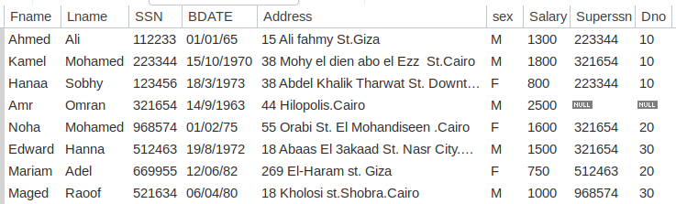

- Display the employee First name, last name, Salary and Department number.
- select Fname , Lname , Salary , Dno from Employee;

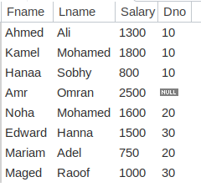

- Display all the projects names, locations and the department which is responsible about it.
- select Pname, Plocation , Dnum from Project;
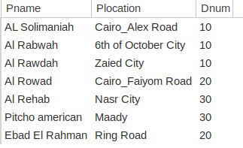

- If you know that the company policy is to pay an annual commission for each employee which specific percent equals 10% of his/her annual salary .Display each employee full name and his annual commission in an ANNUAL COMM column (alias).
- select concat(Fname , Lname) as fullname ,Salary *12*.01 as ANNUALCOMM from Employee;
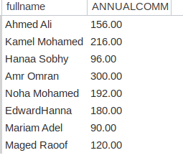

- Display the employees Id, name who earns more than 1000 LE monthly.
- select SSN , Fname , Lname from Employee where salary>1000;

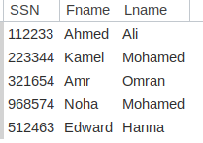

- Display the employees Id, name who earns more than 10000 LE annually.
- select SSN , concat(Fname , Lname) as fullname from Employee where salary*12>1000;

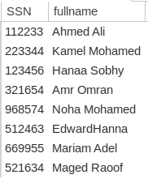

- Display the names and salaries of the female employees
- select SSN , concat(Fname , Lname) as fullname ,salary from Employee where sex='F';

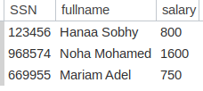

- Display each department id, name which managed by a manager with id equals 968574.
- select Dnum , Dname from Departments where MGRSSN=968574;

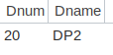

- Dispaly the ids, names and locations of the pojects which controled with department 10
- select Pname , Pnumber from Project where Dnum=10;

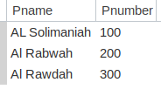

- Display the Department id, name and id and the name of its manager.
- select Departments.Dnum , Departments.Dname , Employee.Fname from Departments inner join Employee on Departments.Dnum=Employee.Dno;
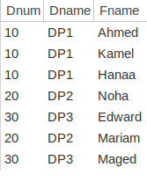

- Display the name of the departments and the name of the projects under its control.

- select Departments.Dname , Project.Pname from Departments inner join Project on Departments.Dnum=Project.Dnum;
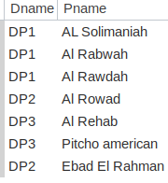

- Display the full data about all the dependence associated with the name of the employee they depend on him/her.

- select Dependent.Dependent_name ,Dependent.Sex ,Dependent.Bdate ,Employee.Fname from Dependent inner join Employee on Dependent.ESSN=Employee.SSN;
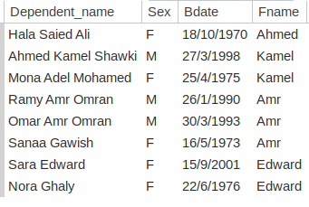

- Display (Using Union Function)
  - The name and the gender of the dependence that's gender is Female and depending on Female Employee.
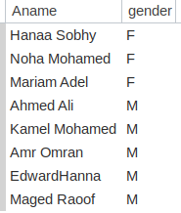
  - And the male dependence that depends on Male Employee.
- select concat(Fname , Lname) as Aname,sex as gender from Employee where sex = 'F' union select concat(Fname , Lname) as Aname,sex as gender from Employee where sex = 'M';

- Display the full data of the employees who is managing any of the company's departments.
- select E.Fname,E.Lname , E.SSN , E.BDATE , E.Address , E.sex , E.Salary , E.Superssn from Employee E inner join Departments on E.Dno=Departments.Dnum;

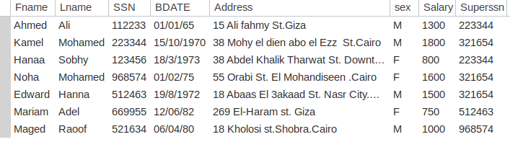

- Display the Id, name and location of the projects in Cairo or Alex city

- select Pname , Pnumber , Plocation from Project where City='Alex' or City='Cairo';

- Display the Projects full data of the projects with a name starts with "a" letter.

- select * from Project where Pname like'a%';

- display all the employees in department 30 whose salary from 1000 to 2000 LE monthly

- select * from Employee where Dno=30 and (salary between 1000 and 20000);

- Retrieve the names of all employees in department 10 who works more than or equal10 hours per week on "AL Rabwah" project.

select concat(Fname,Lname) as FullName , W.Hours , P.Pname from Employee E inner join WorksFor W on E.Dno = 10 and W.Hours >= 10 inner join Project P on Pname = 'Al Rabwah';

- Find the names of the employees who directly supervised with Kamel Mohamed.
?

- For each project, list the project name and the total hours per week (for all employees) spent on that project.
- select P.Pname , W.Hours*7 as HoursPerWeek from Project P inner join WorksFor W on Pnumber = Pno;
- Retrieve the names of all employees who work in every project sorted.

- select distinct concat(Fname,Lname) as AllName from Employee E inner join Project P on E.Dno = P.Dnum;

- Display the data of the department which has the smallest employee ID over all employees' ID.
- select D.Dname , D.Dnum , D.MGRSSN , E.SSN from Departments D inner join Employee E on Dno = Dnum where(SSN = (select min(SSN) from Employee));

- For each department, retrieve the department name and the maximum, minimum and average salary of its employees.
- List the last name of all managers who have no dependents.
- For each department-- if its average salary is less than the average salary of all departments-- display its number, name and number of its employees.
Select

- Retrieve a list of employees and the projects they are working on ordered by department and within each department, ordered alphabetically by last name, first name.
- For each project located in Cairo City , find the project number, the controlling department name ,the department manager last name ,address and birthdate.
- Make a list of all projects’ numbers for projects that involve an employee whose last name is Mohamed, either as a worker or as a manager of the department that controls the project.(solve it with nested Q or union function )

- Display the employee number and name who has no dependent on him/her (use exists).

Data Manipulating Language:

- Insert your personal data to the employee table as a new employee in department number 30, SSN = 102672, Superssn = 112233.
insert into Employee(Fname,Lname,SSN,BDATE,Address,Sex,Salary,Superssn,Dno) values('Mohammed','Saber',102672,'29-29-1995','Mansoura','M',4000,112233,30);

- Insert another employee with personal data your friend as new employee in department number 30, SSN = 102660, but don’t enter any value for salary or manager number to him.
insert into Employee(Fname,Lname,SSN,BDATE,Address,Sex,Dno)
values('Mahmoud','Ahmed',102660,'10-7-1995','Mahala','M',30)

- In the department table insert new department called "DEPT IT" , with id 100, employee with SSN = 112233 as a manager for this department. The start date for this manager is '1-11-2006'

insert into Departments
values('DEPT IT',100,112233,'1-11-2006');
- Do what is required if you know that : Mrs.Noha Mohamed moved to be the manager of the new department (id = 100), and they give you her position
  - First try to update her record in your database.
  - Update your record to be department 20 manager.
  - Update your friend data to be in your teamwork (supervised by you)

a- update Departments set MGRSSN= 968574 where Dnum=100;

b- update Employee set Dno= 20 where SSN=102672;

- Unfortunately the company ended the contract with Mr.Kamel Mohamed so try to delete his data from your database, in case you know that you will be temporary in his position.

- And your salary has been upgraded by 20 present of its las

